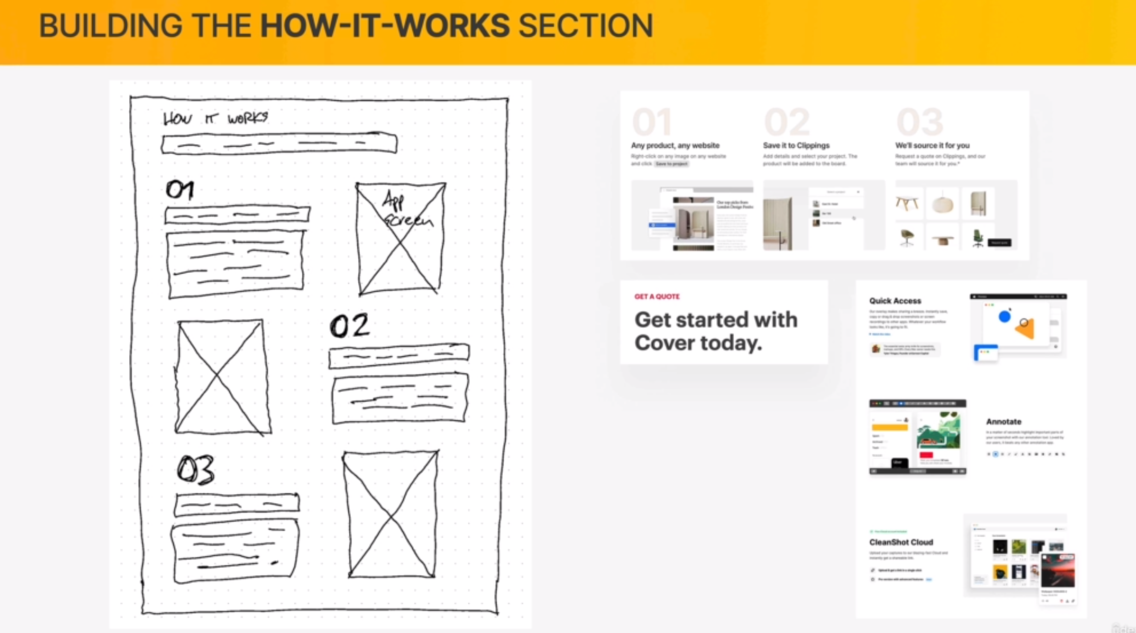

* We are using a Z patter
* Each of the rows will be one of the How it Works steps
* Big Number
* Small text header
* Description
* Image
* Above will be a H2 Headline with the SECTION headline
* Above that will be a small text with what the section is about “How it works”